Lab 16

NOTE: Create a new package for each exercise. You are provided with the code, just make sure that you understand the exercises

Exercise 1: Basic file operations

One of the responsibilities of a web browser (e.g., Internet Explorer, Chrome, etc.) is to manage “cookies” on the computer where the web browser is running. Cookies are small text files containing information about a web site visitor that can be used to determine what information is presented to a visitor when he or she visits a particular web site. For example, amazon.co.uk uses the information stored in cookies to personalize web pages, including displaying a personalized greeting, promoting items that are likely to be of interest to the visitor based on his or her purchase history, etc.

Some cookies exist as long as the browser is open and are deleted when the browser is closed. Other cookies remain until they “expire”. When the browser starts up, it checks for expired cookies and removes them.

In this exercise, you are to create a class that can be used by a browser to manage cookies. The methods in this class must allow the browser to create a cookie, modify a cookie, read a cookie and delete a cookie.

- Download Cookie.java from Moodle. This file contains the method templates you will implement for this exercise.
- Download TestCookie.java from Moodle. This file contains a test driver program that will be used to test your implementation of the Cookie class.
- Modify each of the methods in Cookie.java. Comments are provided in the method bodies to help you determine what needs to be done.
- Hint: implement the methods in the following order: createCookie(), readCookie(), modifyCookie() and deleteCookie(). After you implement each method, compile Cookie.java and run the TestCookie program to test your code.

Code for createCookie()
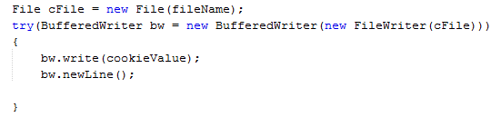

Code for readCookie()
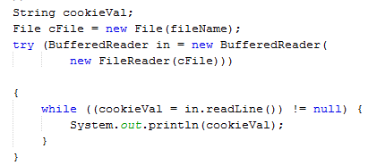

Code for modifyCookie()
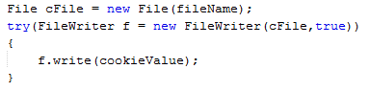

Sample Output

Testing Cookie class

Creating a new file: cookie1.txt

Contents of cookie1.txt:

joebloggs@hotmail.com; date:02112015; searchkey:Christmas+trees

Contents of cookie1.txt after modification

joebloggs@hotmail.com; date:02112015; searchkey:Christmas+trees

joebloggs@hotmail.com; date:03112015; searchkey:Christmas+lights

File deleted

Does cookie exist?

ERROR MESSAGE - activity 1: Exception thrown - file no longer exists

Exercise 2: File properties
The methods you implemented in Cookie.java can be improved by checking file properties before performing operations on the file. For example, before modifying the contents of a cookie file, a check should be made to verify the file is writable, and before a file is read, the code should verify the file actually exists. These types of checks allow the program to handle errors gracefully rather than “crashing.” For this exercise, you will make the following modification to you code to keep it from “crashing” when an invalid request is made:

- Download TestCookie.java from Moodle. Use a copy of your program Cookie.java from the previous exercise
- Modify the readCookie() method to check that the file exists before you attempt to read it. If the file does not exist, print the message “File does not exist” to System.out. Use the exists() method in the File class.

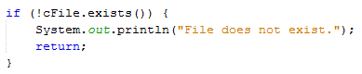

- Comment out line 25 before you move on to the next part of the exercise.
Modify the modifyCookie() method to check that the file is writable before you attempt to update it. If the file is not writable, print the message “modifyCookie() cannot update the file because it is not writable” to System.out.
